Tenda MW5s-If cannot detect connection type when configuring MW5s by Tenda App. What should I do？
If you have static configuration information (Static IP, default gateway, DNS server), please follow the steps:

Step 1: tap “Choose your connection type manually”.

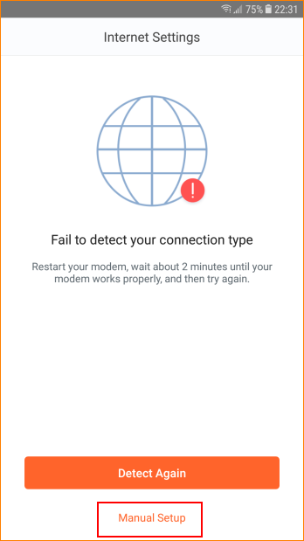

Step 2: Select “Static IP”.

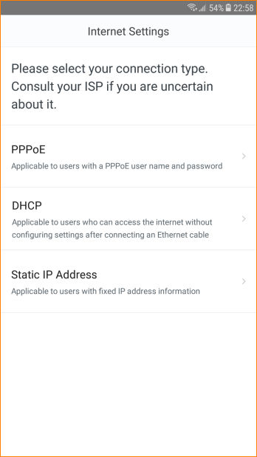

Step 3: Type details, tap “Next”.

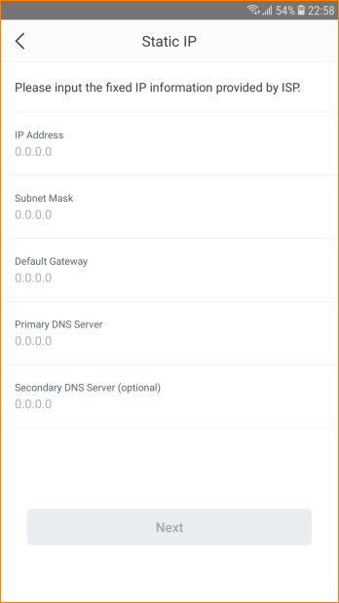

Step 4: Follow the instruction.

If you are not use Static IP connection type, please follow the steps:

Step 1: Power off and power on MW5s and modem.
Step 2: Reconnect MW5s WiFi, close and reopen Tenda App to reconfigure.
Step 3: Plug ethernet cable directly into PC to check if internet access is available. If not, please contact ISP for further help.

